Lovely Professional University

**CA2**

**School:** Mittal School of Business **Lovely Faculty of Business and Arts**

**Name of the Faculty Member:** Logesh Kumar, Rupesh

**Course Code:** MGNM801 **Course Title:** Business Analytics-I

**Section:** Q2240

**Date of Allotment:** 22/12/2022 **Date of Submission:** 29/12/2022

**Attempt (Group/Individual)**: Individual **Max Marks** :30

**Name:** Nowneesh T **Roll No:** RQ2240A19

**Reg No:** 12202342

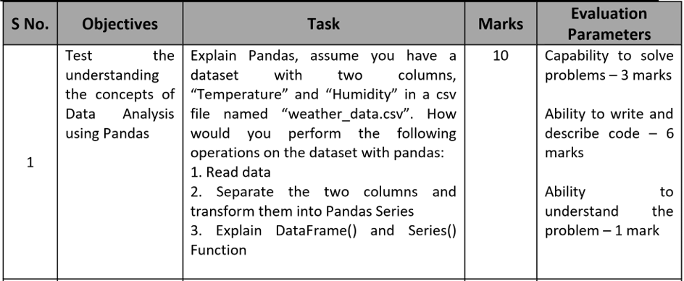

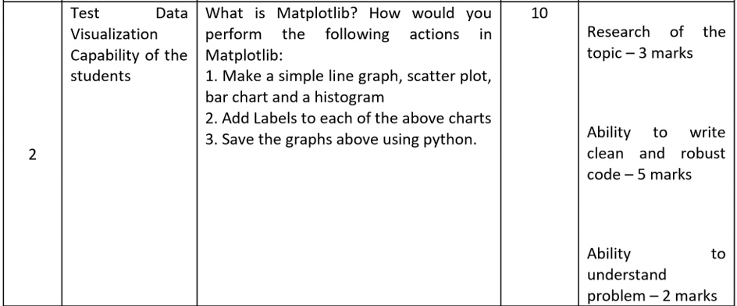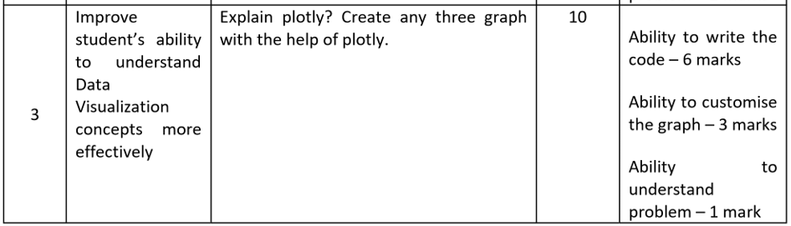

1.Pandas

The data is taken from Kaggle with 5 rows.

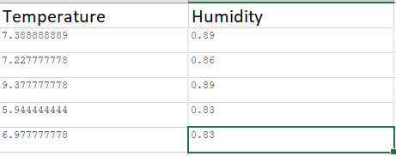

Reading the data

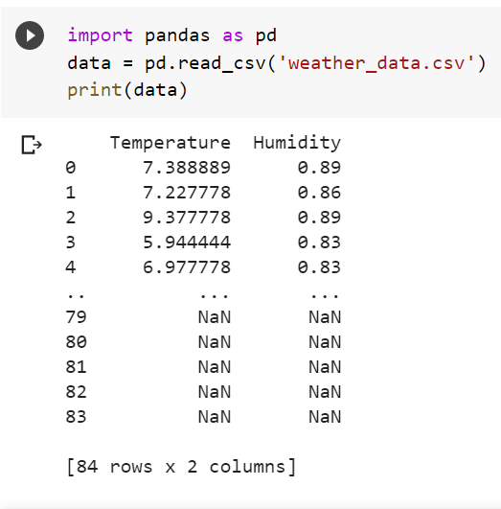

* First, we have to import pandas function.
* Second, we have to read the data from CSV file
* Third, we have to print the data for checking whether data is successfully read or not.

Columns into pandas Series

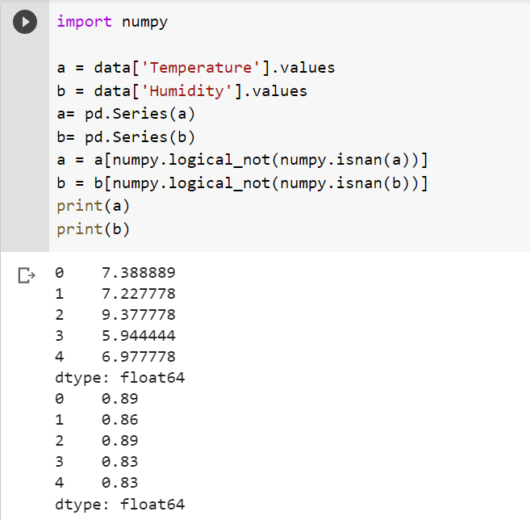

* After reading reading data, we have to separate those data.
* “Series” command is used to split the columns from data variable.
* “is nan” is used to delete unwanted or unfilled data.
* Atlast, we have to print the data.

A Pandas Series resembles a table's column.

* It is a one-dimensional array that can hold any kind of data.
* You are able to name your own labels using the index option.
* When you create labels, you can use the label to get to an item.
* When constructing a Series, you can also utilise a key/value object like a dictionary.

Create a simple Pandas Series from a list:

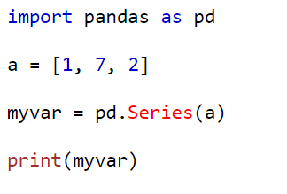

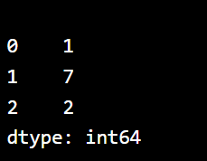

A Pandas DataFrame is a two-dimensional data structure having rows and columns, similar to a two-dimensional array.

* The loc attribute is used by Pandas to return one or more specified rows (s)
* You are able to name your own indexes using the index argument.
* Pandas may load data sets that are kept in files into a DataFrame.

Create a simple Pandas DataFrame:

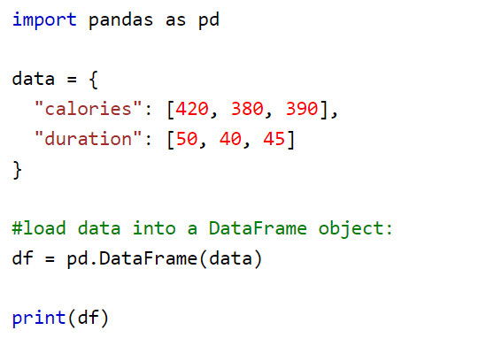

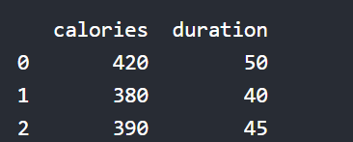

2. MatplotLib

A tool for visualising data, Matplotlib is a low level graph charting framework written in Python.

Since Matplotlib is open source, we are allowed to utilise it.

For platform compatibility, Matplotlib is primarily written in Python, with a small amount of code written in C, Objective-C, and Javascript.

LINE CHART

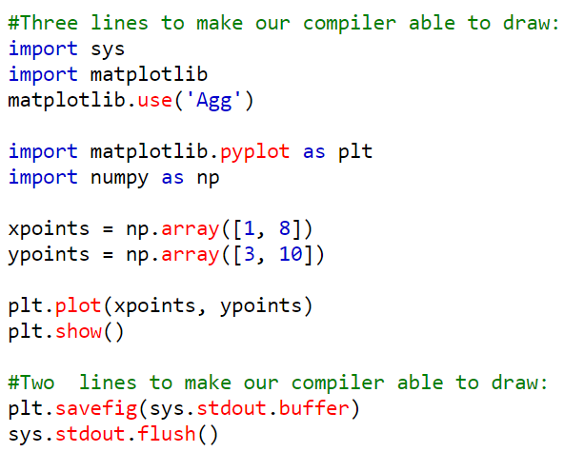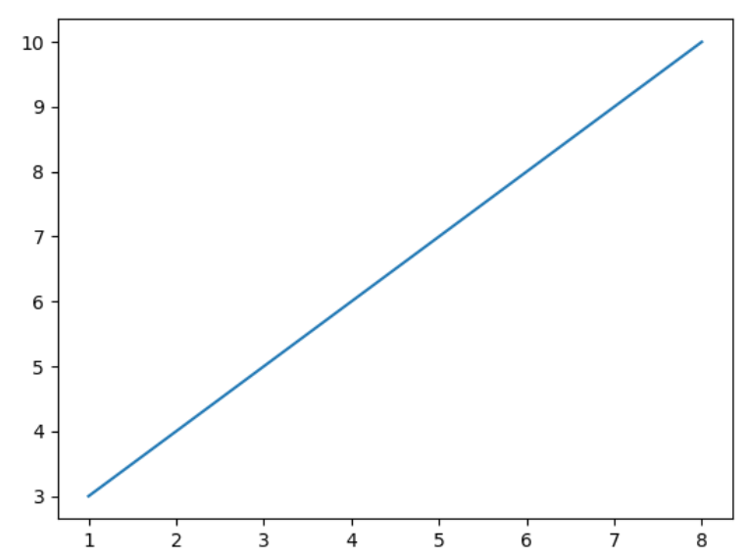

BAR CHART

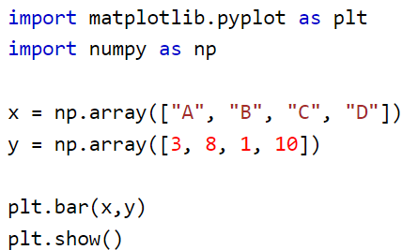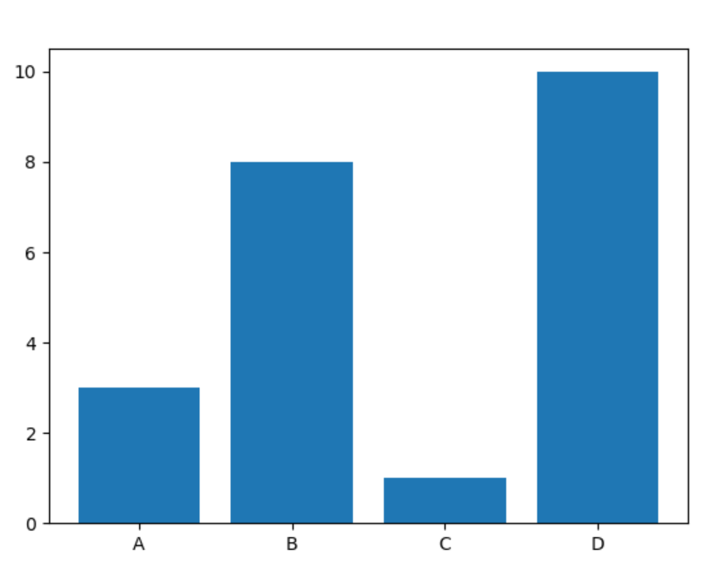

HISTOGRAM

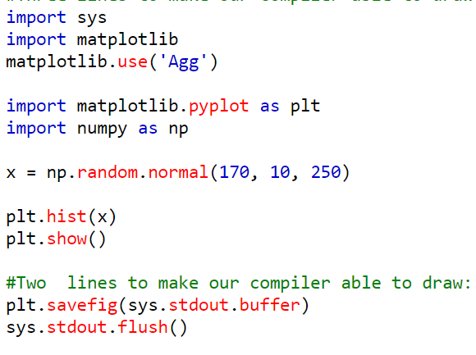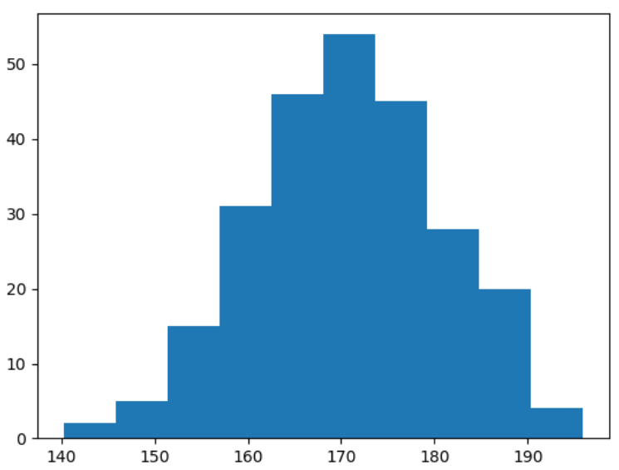

SCATTER PLOT

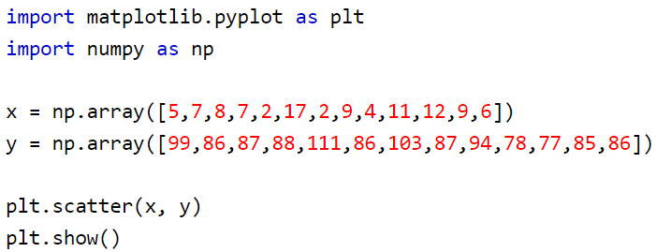

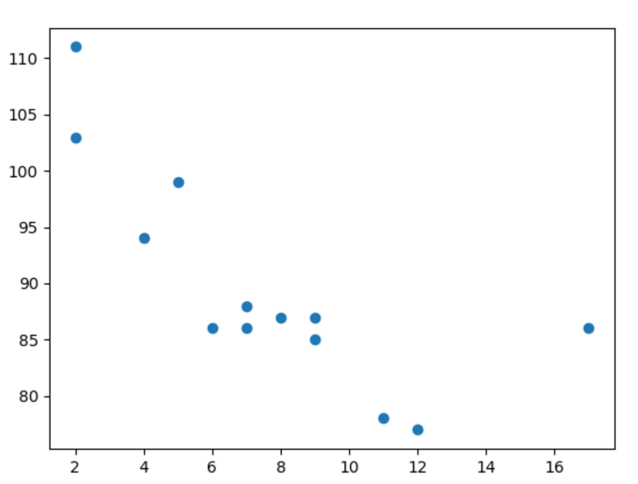

3. Plotly

An open-source library called the Python Plotly Library can be used to quickly and easily visualise data and comprehend it. Plotly supports a number of different plot types, including line charts, scatter plots, histograms, and cox plots.

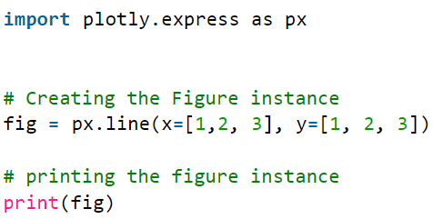

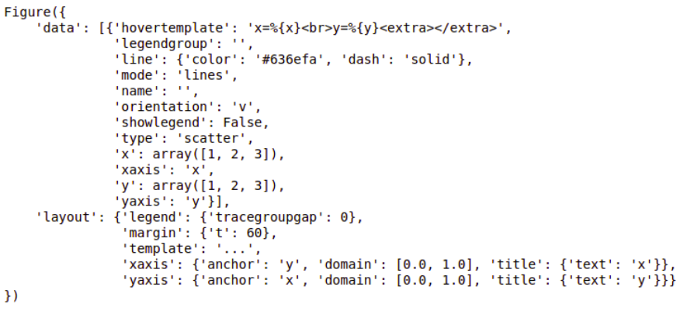

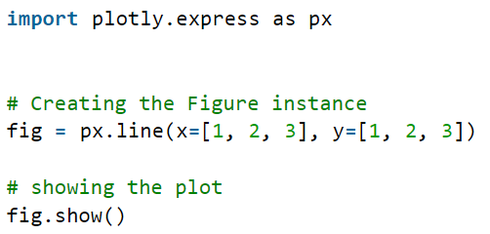

LINE CHART

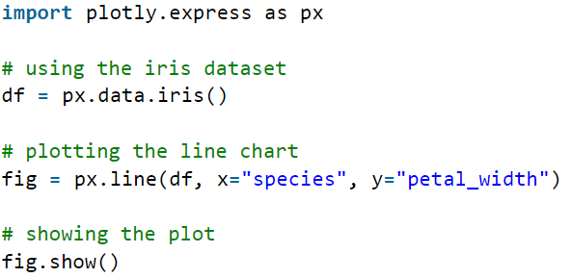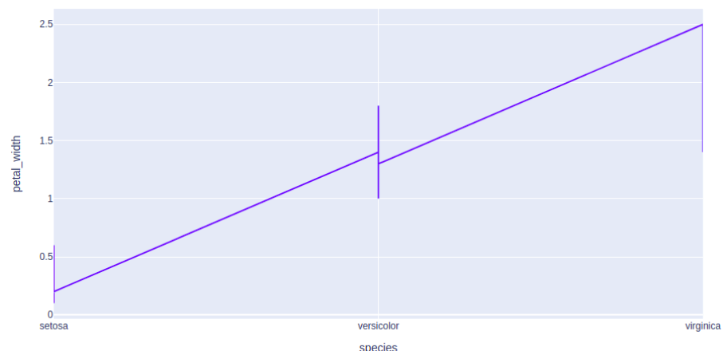

BAR CHART

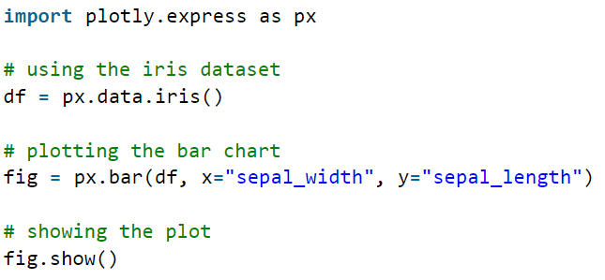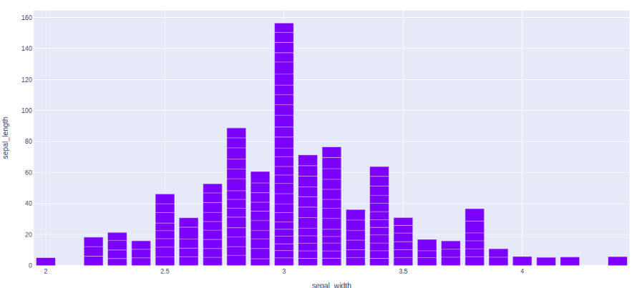

HISTOGRAM

